This workflow automates building a Spring Boot application, storing its container image in Amazon ECR, running it across worker nodes in AWS EKS, and injecting database credentials securely from AWS Secrets Manager without hardcoding passwords.
Step 1 & 2: Build & Push to Amazon ECR
The application code uses externalized environment variables for database credentials rather than hardcoding them.
src/main/resources/application.yml

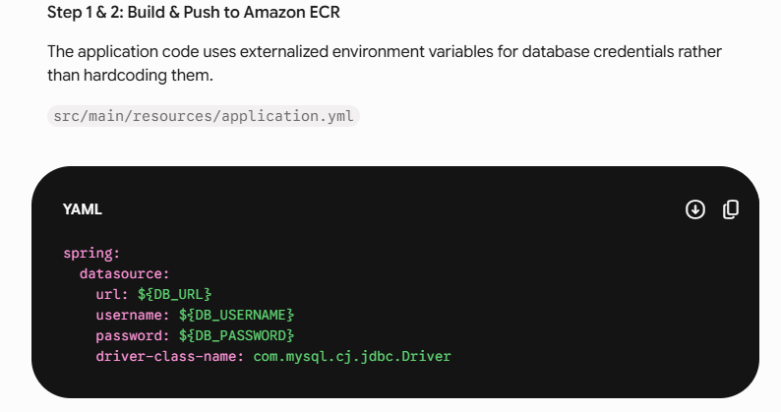

Step 3 & 4: IAM Roles for Service Accounts (IRSA) & Kubernetes Deployment
To access AWS Secrets Manager securely, the EKS Pod uses IAM Roles for Service Accounts (IRSA). This links a Kubernetes Service Account directly to an AWS IAM Role via an OIDC provider.
- Define the Service Account with IAM Role Annotation
service-account.yaml

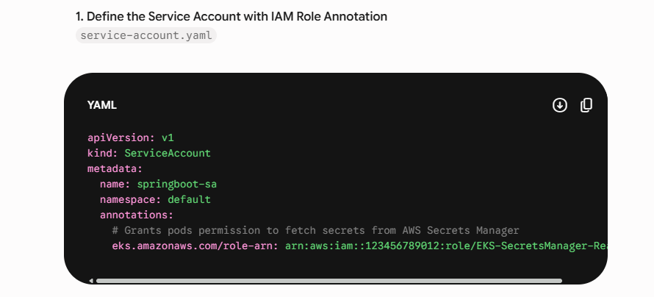

2. Sync AWS Secrets Manager to a Kubernetes Secret
Using the External Secrets Operator, AWS Secrets Manager key-value pairs (prod/rds/credentials) are continuously synced into a standard Kubernetes Secret.

external-secret.yaml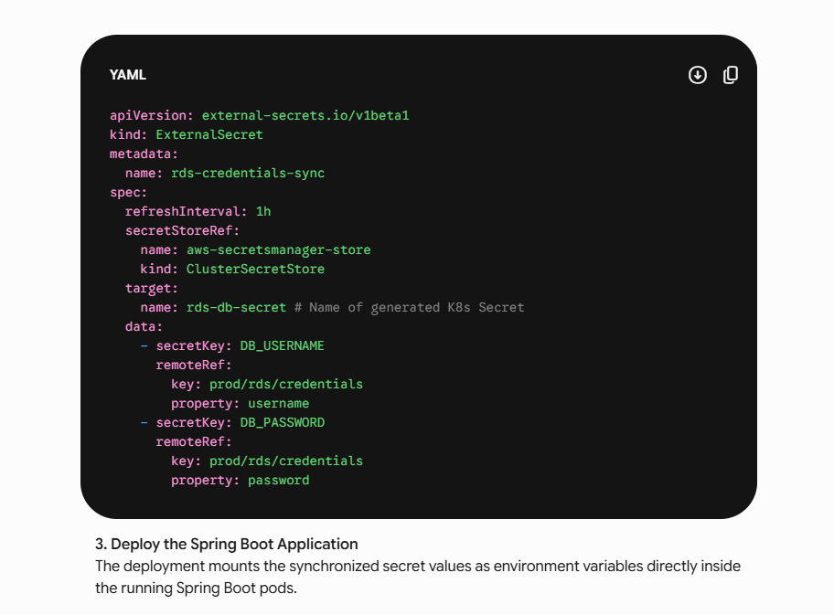

3. Deploy the Spring Boot Application The deployment mounts the synchronized secret values as environment variables directly inside the running Spring Boot pods.
deployment.yaml
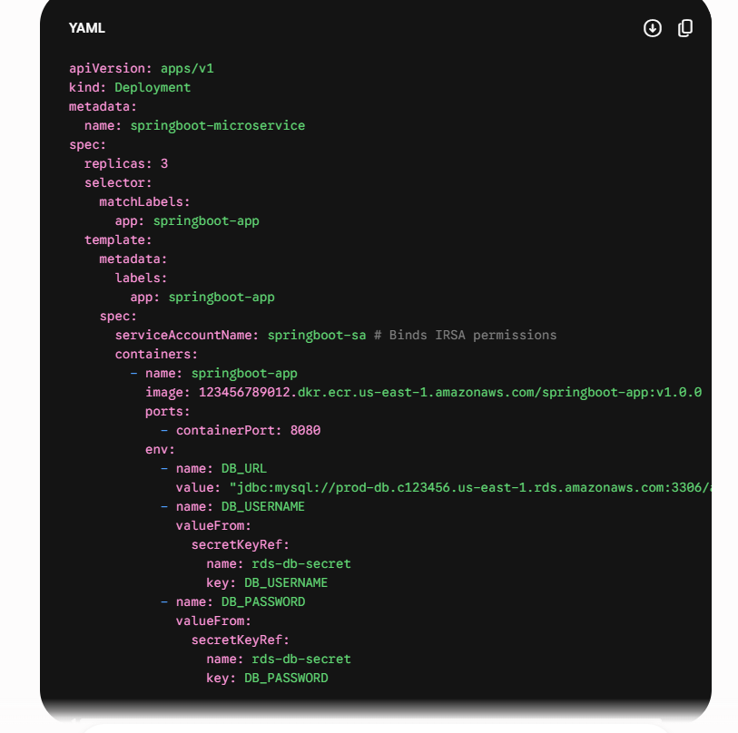

Complete overview of code:
2. Infrastructure & Kubernetes Configurations
A. Kubernetes Service Account with IRSA Integration (service-account.yaml)
Associates the Kubernetes Service Account with an AWS IAM Role via OpenID Connect (OIDC).
YAML
apiVersion: v1
kind: ServiceAccount
metadata:
name: springboot-sa
namespace: default
annotations:
[eks.amazonaws.com/role-arn](https://eks.amazonaws.com/role-arn): arn:aws:iam::123456789012:role/EKS-SecretsManager-Read-Role
B. AWS IAM Policy (Least Privilege Access)
The IAM policy required by the EKS-SecretsManager-Read-Role role:
JSON
{
"Version": "2012-10-17",
"Statement": [
{
"Effect": "Allow",
"Action": [
"secretsmanager:GetSecretValue",
"secretsmanager:DescribeSecret"
],
"Resource": "arn:aws:secretsmanager:us-east-1:123456789012:secret:prod/rds/credentials-*"
}
]
}
C. ClusterSecretStore Configuration (cluster-secret-store.yaml)
Configures the External Secrets Operator to use AWS Secrets Manager with IRSA authentication.
YAML
apiVersion: external-secrets.io/v1beta1
kind: ClusterSecretStore
metadata:
name: aws-secretsmanager-store
spec:
provider:
aws:
service: SecretsManager
region: us-east-1
auth:
jwt:
serviceAccountRef:
name: springboot-sa
namespace: default
D. ExternalSecret Sync Definition (external-secret.yaml)
Fetches secrets from AWS Secrets Manager and creates a native Kubernetes Secret.
YAML
apiVersion: external-secrets.io/v1beta1
kind: ExternalSecret
metadata:
name: rds-credentials-sync
namespace: default
spec:
refreshInterval: 1h
secretStoreRef:
name: aws-secretsmanager-store
kind: ClusterSecretStore
target:
name: rds-db-secret # Name of created Kubernetes Secret
creationPolicy: Owner
data:
- secretKey: DB_USERNAME
remoteRef:
key: prod/rds/credentials
property: username
- secretKey: DB_PASSWORD
remoteRef:
key: prod/rds/credentials
property: password
E. Kubernetes Deployment Manifest (deployment.yaml)
Deploys the Spring Boot microservice, referencing the service account and environment variables sourced from the synced secret.
YAML
apiVersion: apps/v1
kind: Deployment
metadata:
name: springboot-microservice
namespace: default
labels:
app: springboot-app
spec:
replicas: 3
selector:
matchLabels:
app: springboot-app
template:
metadata:
labels:
app: springboot-app
spec:
serviceAccountName: springboot-sa
containers:
- name: springboot-app
image: [123456789012.dkr.ecr.us-east-1.amazonaws.com/springboot-app:v1.0.0](https://123456789012.dkr.ecr.us-east-1.amazonaws.com/springboot-app:v1.0.0)
imagePullPolicy: IfNotPresent
ports:
- containerPort: 8080
env:
- name: DB_URL
value: "jdbc:mysql://[prod-db.c123456.us-east-1.rds.amazonaws.com:3306/appdb](https://prod-db.c123456.us-east-1.rds.amazonaws.com:3306/appdb)"
- name: DB_USERNAME
valueFrom:
secretKeyRef:
name: rds-db-secret
key: DB_USERNAME
- name: DB_PASSWORD
valueFrom:
secretKeyRef:
name: rds-db-secret
key: DB_PASSWORD
resources:
requests:
memory: "512Mi"
cpu: "250m"
limits:
memory: "1Gi"
cpu: "500m"
Key Security & Architectural Benefits
- No Hardcoded Credentials: Passwords and keys are excluded from git repositories, docker images, and Kubernetes manifests.
- Granular Role Isolation: IAM Roles for Service Accounts (IRSA) restrict AWS access per pod rather than per EC2 worker node.
- Automatic Rotation: The External Secrets Operator periodically syncs with AWS Secrets Manager, picking up rotated passwords without requiring cluster restarts.
- Centralized Audit Logging: Every secret fetch attempt is logged in AWS CloudTrail for compliance monitoring.

